**Practicum Report**

Job sheet 3

Assignment 3: Assignment

Variables, Data Types, and Operators



MUHAMMAD BAIHAQI AULIA ASY’ARI

2241720145

CLASS 1I (INTERNATIONAL)

INFORMATICS ENGINEERING­­

INFORMATICS TECHNOLOGY

STATE POLYTECHNIC OF MALANG

Contents

Assignment 3

1 3

2 4

# Assignment

## 1

Pay attention to the following table:

|  |  |  |  |
| --- | --- | --- | --- |
| Variable Name | Data Type | Initial Value | Description |
| campus | Sentence | Polinema | - |
| grade | Integers | 1 | - |
| class | Character | Z | Initial value = your class |
| integer | Integers | 10 | - |
| number | Floating point | 3.33333 | - |
| character | Character | C | - |

From the table information, create a program to display the results as shown below!

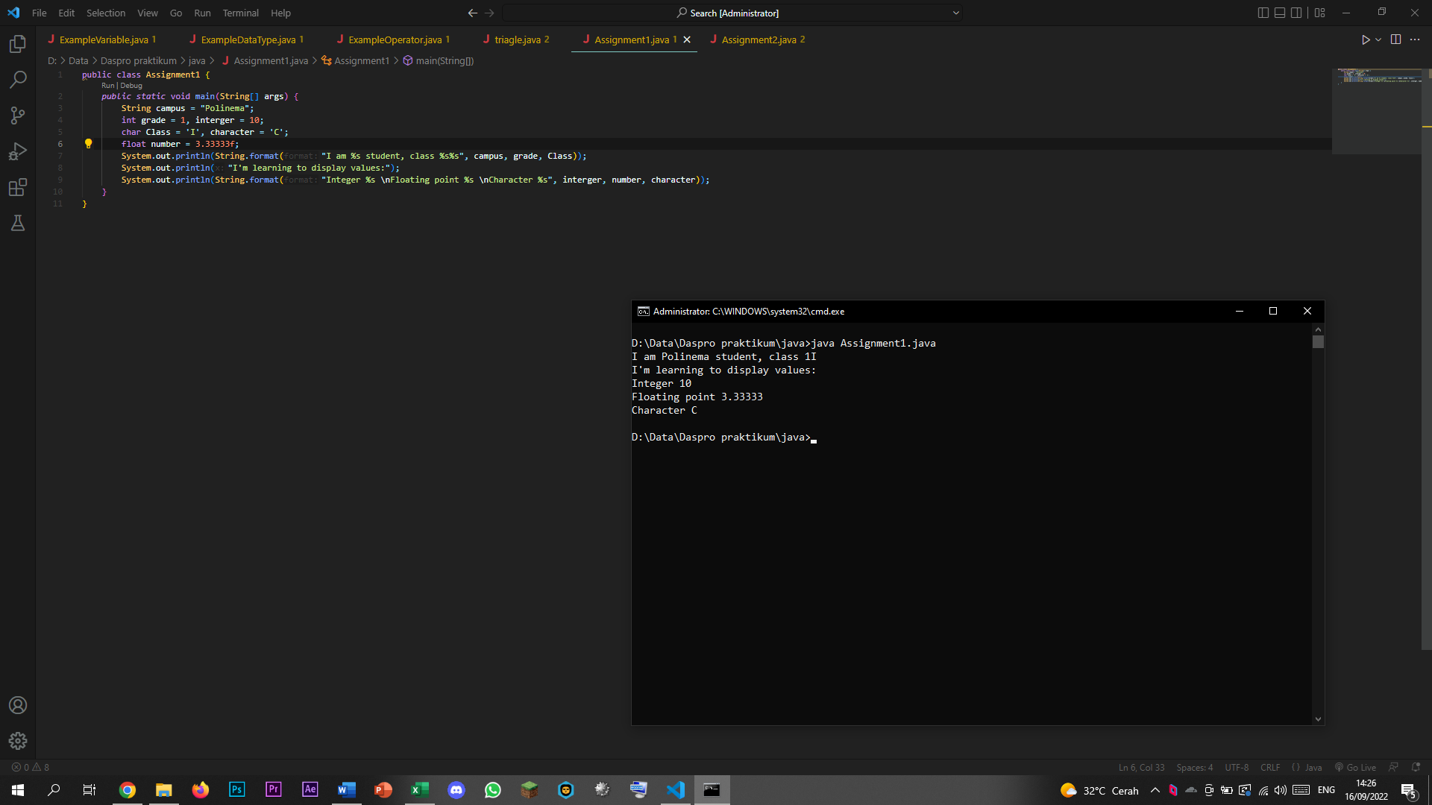

## 2

Observe the flowchart to convert temperature

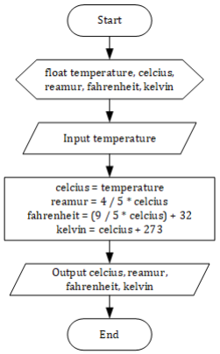

Implement the flowchart into the program using the Java programming language!

